First Year PhD Progress Report
3rd July 2018

Robert William Hickman



Supervisor: Prof. Wolfram Schultz
Advisors: Dr Steve Edgley, Dr Hannah Clarke
Introduction
The fundamental purpose of the brain is to generate a response suitable to the environment to maximize an animal’s well-being. Whether avoiding a predator or writing a fellowship application, behavioural decisions rely on some 'subjective value' that is assigned to each outcome. The aim of any rational decision is to maximise utility—the subjective value of reward— making this valuation the critical parameter in the decision making¹. Therefore, appropriate reward valuation is essential for maximising survival and gene propagation.

In contrast to how the visual system may pick out salient threatening features of a predator, rewarding stimuli typically have no clear or consistent external cue of value. For instance, a small, clear, diamond may have a higher reward magnitude than a large house with all its various features. This perceived value reflects the animal’s requirements and desires, an internally generated abstraction of the stimuli. Thus, to correlate brain activity with utility, to understand the neural mechanisms of decision-making, an explicit statement by the animal of their valuation is necessary: their revealed preferences on behavioural tests.

Such declarations are simple to gather from humans². However, investigation of neuronal decision-making mechanisms with high spatial and temporal resolution requires the recording of single-neuron activity, necessitating the use of animal models. For example, single-neuron electrophysiological recordings in monkeys have laid the groundwork for the nascent field of neuroeconomics, which aims to establish a relationship between economic decision-making and the neural mechanisms of decision^{3,4}. In these studies, inferences about value are made from revealed preferences – i.e. preferences inferred based on choices made between two different rewards, for example, different kinds of fruit juice. A limitation of this approach is that, to achieve even a single reliable value estimate, many binary choices must be presented to a monkey, increasing measurement time and noise present in monkeys’ evaluations. Furthermore, estimating subjective value from the average of many choices discards any genuine moment-by-moment fluctuations in the monkey’s valuation of the rewards (e.g. due to satiation⁵).

These limitations can be overcome by using an auction mechanism commonly used in behavioural studies of human decision-making. Becker et al.⁶ developed an auction task to overcome “the assumption that the subject’s probabilities of choice remain constant throughout the many times that he is choosing from the same available set of actions”. In a Becker-DeGroot-Marschak (BDM) auction, the subject makes a bid for a reward which is compared to a bid made by a random number generator⁶. If the subject’s bid is higher than the computer’s bid, they win the auction, pay the randomly generated (lower) amount and receive the good, else, they pay nothing, but don't receive the auctioned good. The optimal strategy in such ‘second-price’ auctions is to bid the highest amount a subject is willing to pay, that is, exactly the subject's subjective value of the reward.

The BDM therefore elicits a single trial readout of the absolute value of a reward, instead of the trial-by-trial ratios obtained in a binary choice. Human studies of subjective valuation have used the BDM to show areas of the brain analogous to those found in binary choice studies in monkeys⁴ are involved in tracking the value of an offered good⁷, though these relied on using the less precise method of fMRI, which only indirectly records brain activity.

We will record from single neurons in monkeys performing the BDM task, to find the neuronal correlates of moment-to-moment behavioural expressions of valuation. To achieve this in such a complex task, we have first focused on reproducing work from within the lab using this novel paradigm and have adapted it for neurophysiological recording. The Schultz lab has experience recording the encoding of difference between the subjective value of outcomes from the expected subjective value by midbrain dopamine neurons, commonly referred to as reward prediction error (RPE)³. Comparing the RPEs of these neurons with the bid for an offered good provides a moment-by-moment test for the BDM's ability to capture subjective value.

The aim of this project is to correlate the activities of single neurons with the monkey’s willingness-to-pay in a BDM trial, recording from both midbrain dopaminergic neurons and higher cortical structures, such as the orbitofrontal cortex (OFC). Combining the explanatory power of recording single neurons with the single-trial information of the BDM auction paradigm may allow us to identify specific signals involved in single valuation decisions- e.g. the outcome of the previous trial. The auction task also mirrors the richness human valuation of goods, bridging the gap between biological rewards in animals and economic decision-making in humans.

Materials and Methods
Two male (9.1kg, 15.22kg; 7 years old) rhesus macaques (Macaca mulatta) with previous experience of similar behavioural tasks were used for all experimental studies (monkey U and monkey V, respectively). All protocols were assessed and approved by the Home Office of the United Kingdom.

The animals sat in a primate chair (Crist Instruments), 50cm away from a computer monitor displaying the task. A custom-built joystick (Biotronix workshop) was used to manipulate bidding indicators. Throughout, deflection-evoked changes in voltage supplied to MATLAB from this joystick were sampled at 200Hz and controlled the position of bidding indicators using the following formula:
x_{(t)} = x_{(t−1)} + GV_{(t−1)}

Where x(t) is the position within the bidding space of the monkeys at time t. The movement is proportional to sampled voltage multiplied by a gain factor (G).

Liquids were delivered via solenoid valve which led to taps at monkey’s mouth level. Both tasks were run on MATLAB 2018a (Mathworks, 2018) on a Windows 7 operating system. Task code is stored and version-controlled at GitHub⁸.

Behavioural Tasks
Monkeys were trained to hold a joystick in an upright position. A fractal which the monkeys had learned represented an amount of juice reward was displayed. Monkey’s had to choose whether to forgo water to earn the juice offered by this fractal. Fractals representing offered juice varied by magnitude (in ml) within a single block, but also by concentration and flavour between blocks.

In the tasks, water is represented as a hatched black and white bar. A full bar represents a maximum amount of 1.2ml of water per trial. The reversal of the hatch pattern indicates water which is not available to the monkey, either because it has been ‘paid’ in the auction task, or not offered as part of a bundle. These stimuli are outlined in figure 1.

Pavlovian Training Task
To train monkeys on magnitudes of juices reward indicated by fractals, they received free rewards in a simple task in which a fractal was displayed, and the corresponding juice released (figure 1E).

A version of this task with low-magnitude, probabilistic fractals is also used before bundle choice and auction tasks in preparation for electrophysiological recording. The evoked RPEs will allow for the identification of RPE encoding neurons without satiating the monkey prematurely.

Bundle Choice Task
To verify that monkeys’ order of preference reflects the magnitudes of fractals, and to get references values of each fractal in terms of water, monkeys were trained on a binary choice task.In standard binary choice tasks, monkeys repeatedly choose between two options. In this case these would be represented by a fractal, and a hatched bar indicating varying amounts of water. The amount of water that must be offered for a monkey to choose the fractal or the water equally is referred to as the ‘indifference point’ and reflects the subjective value of the fractal in terms of water.

To ensure that our task provides an analogous choice to the BDM with regards to the monkey’s overall payoffs in each trial, we had to modify this standard procedure. We used a binary choice task that is mathematically identical to the BDM (supplementary figure 1). The monkeys chose between either the full amount of water or the fractal alongside some proportion of the water, henceforth referred to as the ‘bundle choice task’, or BCb.

In the BCb, monkeys make a certain choice between a ‘bundle’ of juice and water, or 1.2ml of water (the maximum water offered per trial). Bundles were presented in a pseudo-random order to maintain equal numbers of trials per bundle over a session. In total, 30 different bundles were presented to the monkey per block, representing each combination of juice reward magnitude and 10 different water amounts (0.12-1.2ml of water in 0.12ml increments).

Monkeys indicate a choice by moving a central dot on the screen left or right using the x axis of the joystick. Once the dot is within the outermost 40% of the screen on either side, it must be left in place for 2 seconds. The images representing the chosen offer remain on the screen as any juice, followed by water, is released. This is shown in figure 1C.

Reference subjective values of each fractal in terms of water were calculated by fitting a logistic regression curve to the choice data. This 'indifference point' value was then calculated as the total budget minus the water that needed to be offered for a monkey to choose the bundle 50% of the time. This indifference point should be equal to the monkey’s value for the reward.

Becker-DeGroot-Marschak (BDM) Auction Task
Monkeys are presented with a fractal and a ‘full’ hatched bar representing a budget of 1.2ml of water (figure 1A). For each trial, the monkey is first presented with the fractal (which is kept separate from other stimuli to isolate it’s associated RPE), and then the budget bar. Once the budget appears on the screen, monkeys can indicate their bid by moving a red bar vertically using the y axis of the joystick. Once the monkey places a bid which is stationary for 2 seconds, the bar locks in place and further bidding is impossible. For each trial, the bar indicating the monkey’s bid starts either at a random position within the budget. This variety in start position precludes the monkey from learning a simple stimulus-response relationship for each fractal presented. Instead, the monkey must move their bid different distances and directions to reflect their subjective value.

A computer bid is then generated from a uniform distribution and is represented by an identical bar which is green in colour. If the monkey’s bid is higher than the computer’s bid the monkey ‘wins’ the auction, whereas if it is lower, the monkey ‘loses’.

In the win condition, the monkeys ‘pays’ the second price to win the juice, i.e. he forgoes an amount of water equal to the computer’s bid but receives the remaining water and the juice indicated by the fractal. The fractal remains on the screen, and the portion of the hatched bar below the computer’s bid reverses its pattern to represent water forgone. The earned juice and water are then released from the solenoid respectively. If the monkey loses the auction, the fractal stimulus disappears, and he only receives all the budget 1.2ml of water.

First Price Auction Task
Monkey V was trained on a separate task to investigate the differences in behavioural contingencies between second price auctions, as described above, and first price auctions (in which the winner pays their bid for a good). Where the BDM is truly incentive compatible (the best strategy is always to bid true subjective value), first price auctions incentivise bid 'shading' and the optimal strategy for uniform opponent bidding is instead to bid exactly half the subjective value of a good on each trial. The first price task was otherwise identical to the BDM task

Due to differences in weight and task behaviour, this task was run for ~200ml (V's daily liquid requirement) per day to encourage optimal bidding strategies. This experimental work was aided by Marius Posa, a part II student in the lab.

Electrophysiological Recording
In preparation for electrophysiological recording, U was trained to perform tasks with his head fixed in place. In summer 2017, a headpost was attached to the skull of monkey U under anaesthesia, and the area was left to heal. Over a period of two months, the monkey was gradually habituated to having his head fixed in place via this post, and then to perform tasks whilst head-fixed.

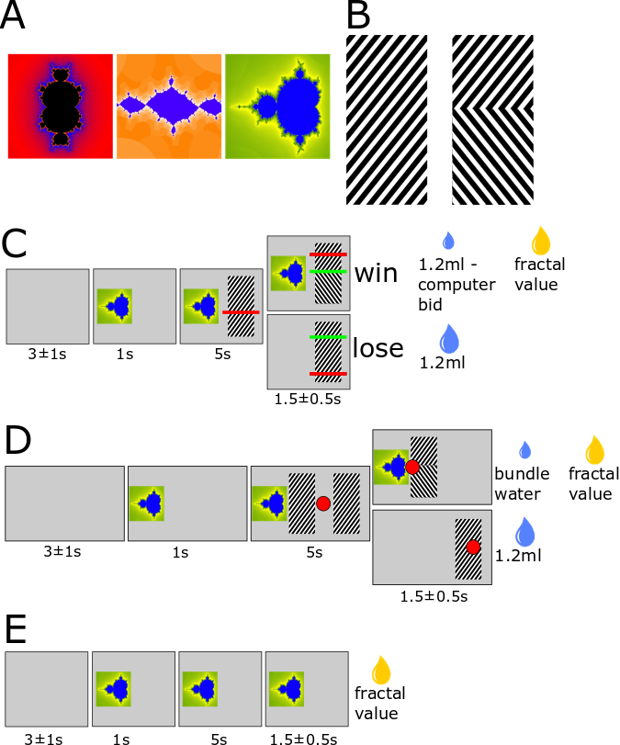
Figure 1: A) An example set of fractals used as stimuli to represent different magnitudes of juice. Fractals are chosen so that for any set, the monkey should have no problem discriminating between them. B) The hatched bar used to represent the full budget of either task (1.2ml water). The reversal of the hatched pattern represent water that the monkey will not receive, in this case 60% of the budget (0.72ml), leaving 0.48ml to be paid. C) The BDM auction task. After an inter trial interval, the monkey is presented with a fractal representing juice. The budget and monkey’s bidding bar (red) then appear together and bidding may commence. Once the bidding epoch is over, a randomly drawn computer bid (green) is revealed. The monkey then either ‘wins’ and pays the computer’s bid in water to receive the juice represented by the fractal, or loses, and receives the full water budget. D) The Bundle Choice task. The monkey is presented with a fractal after an intertrial interval as in the BDM. They must then choose either a bundle of juice + water, or the full water budget, which is then paid out. E) The free juice task. A monkey is presented with a fractal which is eventually paid out in terms of the juice it represents.
Figure 1

To reduce the noise in neuronal activity during trials, the tasks were slightly modified from previously described versions (Al-Mohammad and Schultz, 2018).

Primarily, each task was reduced to just 4 epochs (figure 1):
- a blank inter-trial interval
- a fractal offer epoch- where only the fractal is present
- a bidding/choice epoch in which budgets appear and the monkey must indicate his choice/bid using the joystick
- a payment epoch in which the stimuli encoding paid values (e.g. the fractal and percentage of budget in a bundle) remain on the screen and earned juice, then water, are paid out

The reduction in epochs makes the task more difficult as instead of appearing slowly, multiple stimuli (e.g. the budget and monkeys bidding bar) appear together and as bidding begins. However, this is required to gather sufficient neuronal data per epoch and reduce the number of stimuli neurons might respond to. RPEs can occur on the order of 0.5s after the presentation of a salient stimuli, and to minimise the chance of recording RPEs from previous epochs, each epoch had to be at least this long.

Stimuli which weren’t essential to the task were also removed. For instance, instead of changing colour to indicate the beginning and end of bidding, the bar indicating the monkey's bid remained a constant colour throughout. Monkeys had learnt that
occlusion of the budget indicated water which would not be paid out. However, the stimuli are relatively large, and the change in luminosity from the occlusion extremely salient, which can elicit dopaminergic responses⁹. The budget stimulus was replaced by a hatched black and white pattern. To indicate the loss of water from this budget, the hatched pattern reversed, maintaining the overall luminosity of the stimulus.

Once trained, the monkey will be implanted with a cranial window which will allow for the insertion of electrodes into the brain. This is provisioned to take place in September 2018.

Analysis
All analysis was performed using R 3.4.2. Complete reproducible analysis scripts are maintained in the same GitHub repository as the task code.

Results
All primary data shown is from monkey U, under head fixed conditions, unless otherwise specified.

Bundle Choice Task
Monkeys were retrained on the BCb and produced indifference curves which showed clear ranking of the fractals in order of juice magnitudes (figure 2A). Given that the indifference points were to be used for later auction task blocks, these had to lie between 0ml and 1.2ml (the full auction task budget) of water which required fine tuning of values, until consistent indifference points within the desired range were obtained.

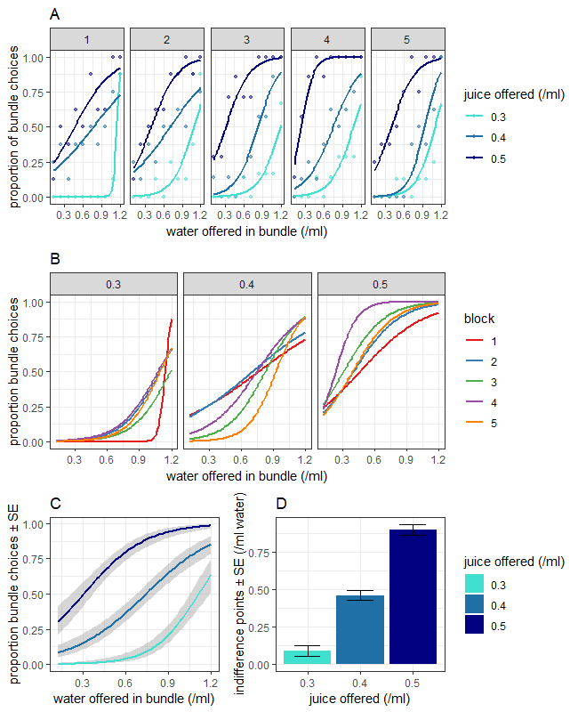
Figure 2: A) Bundle Choice task data for an example week. The logistic regression of the fraction of times the monkey chose the bundle over the budget vs. the water offered in the bundle is plotted. Curves are separated by day and by amount of juice offered in the bundle. Monkeys show clear transitivity on the bundle task, choosing a bundle containing a larger magnitude of juice more frequently for any given bundle water amount. B) Bundle choice regressions show stability over multiple days. C) Pooling the bundle choice data allows us to gather the monkeys indifference point for a given magnitude of juice. Indifference points are calculated as the amount of water that needs to be offered in a bundle for a monkey to be expected to choose that bundle exactly 50% of the time. This is calculated from the logistic regression equations plotted in C. D) Indifference points for the 3 magnitudes of juice for the shown data. Indifference points were significant between juice fractals (p < 0.005)
Figure 2

Regression of bundle choice vs. features of both the trial and the monkeys progression through the experimental block showed that the magnitude of juice and the magnitude of water offered in the bundle were by far the most significant variables (supplementary figure 3). However, monkeys also showed a clear side bias, and a clear effect of trial number on choice behaviour, where they preferred to choose away from the bundle in early trials to receive the full budget
volume. This may reflect the monkey’s preference for large volumes of liquid initially, while they are most dehydrated, before switching to choosing the juice of lower volume but more desirable taste.

To gather more precise indifference points, data was pooled across consecutive days over a week of experiments (figure 2C). Indifference points showed significant differences and were rank ordered for both monkeys.

BDM Auction Task
Monkey U was retrained on the modified task while head fixed. Bids for fractals representing different magnitudes of juice showed rank ordered behaviour, with lager bids for greater juice magnitudes (figure 3A). When comparing bids to indifference points gathered using the Bundle Choice task, the monkey shows similar evaluations of value for the same rewards in both incentive compatible tasks (figure 3B).

In contrast to the BCb which requires ~200 trials to show significant choice differences, a Welch test showed significant differences between bids for fractals at most by 150 trials (figure 3C). Rank ordering of bids by final position and distance moved showed a mean Spearman's coefficient of 0.595, which was significantly lower than from data gathered pre-headfixation training¹⁰.

Regression of bids by juice offered, start position, and by experimental progression such as juice and water earned showed that the juice offered on each trial was the most important variable predicting the monkey’s bid (figure 4B).

Of interest to us was how a monkeys bidding behaviour changes over time, especially given the significant effect of trial number in the Bundle Choice task. Supplementary figure 7 shows the data from figure 3B plotted with a rolling mean of the last 10 bids for each reward. Mean bids remain significantly separated for a substantial portion of the experimental block.

Finally, though initial data (figure 3) showed that the monkey can do the task under head-fixed conditions, recently there has been a decline in performance. Though monkey U still rank orders bids well (supplementary figure 6), the Spearman’s rho coefficient for each day of more recent data is lower than initial values (figure 4D) and lower still than the pre-headfixation¹⁰.

First Price Auction Task
Monkey V had previously been trained on the otherwise identical BDM (second-price) auction task so was retrained to learn the new task contingencies.

V showed significant differences in mean bid between fractals of different magnitudes as measured with a Welch's t-test (supplementary figures 8 and 9).

Figure 3

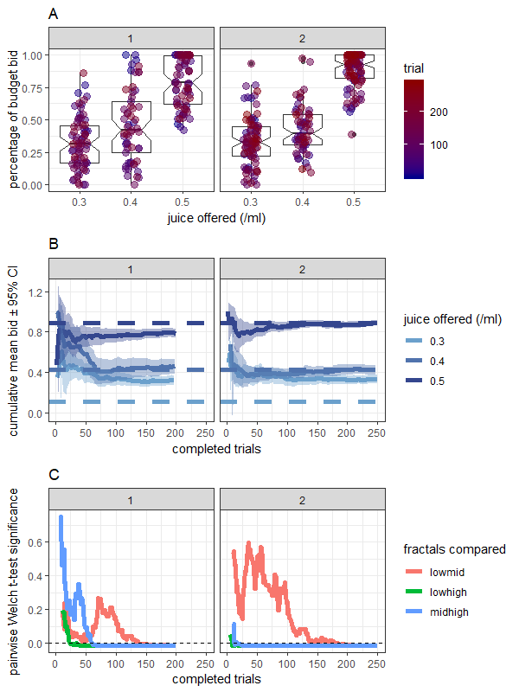
Figure 3: A) Monkey bids for different fractals representing magnitudes of juice on initial experimental blocks of retraining on the BDM task. All bids are expressed as a fraction of the total budget which in this case was 1.2ml of water. B) Cumulative mean bids per fractal made by the monkey in terms of the water in the budget. Initial bids tend to be noisier before settling to a fairly consistent level. Error bars show 95% confidence intervals for the cumulative mean bid. Cumulative means and standard errors were calculated using the zoo library in R. C) The pairwise significance of the different mean bids for each fractal-fractal combination. At any trial n, the mean bids are compared using a Welch’s t-test for unequal variances. The p value returned from this test is compared to a Bonferroni corrected threshold of 0.05 (for 3 fractal-fractal combinations = 0.0166). All 3 fractal-fractal combinations pass under this threshold within 200 trials on the BDM, with the highest fractal showing significant differences within 50 trials.
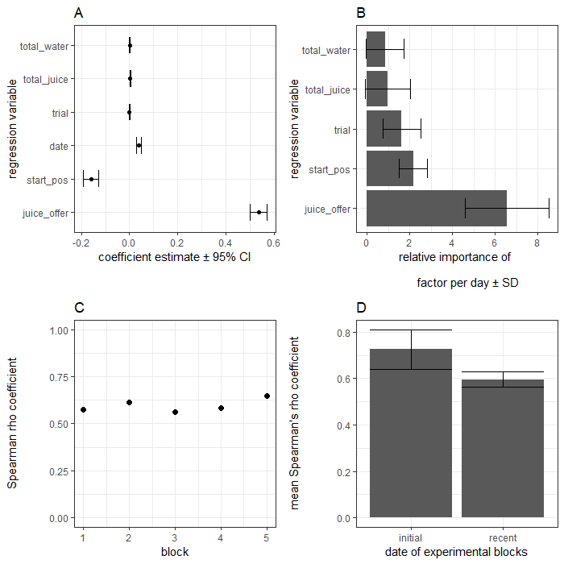
Figure 4: Statistical analyses of recent data for headfixed monkey U on the BDM A) Regression coefficients for the BDM data shown in Figure 3. Factors from both the stimuli from each trial (juice offered, starting position), the experimental block (date), and the monkeys progression through the block (trial, total water consumed, total juice consumed) were regressed against the monkey’s bid. Linear regression models were generated using the binomial family of models for the lm() function from the stats library in R. The juice offered on each trial was significant (p < 2x10⁻¹⁶) . The starting position of the bid (p < 0.0000005) and the date of the block (p < 0.00005) were significant. The juice offered in each trial had by far the largest regression coefficient. B) The mean relative importance of each factor for the linear regression models of a single day’s behaviour. T statistics for each variable from a logistic model is calculated by comparing reductions in generalised cross-validation from variable reduction, and was performed using varIMP() from the caret library in R. C) The Spearman’s rho coefficient for the monkeys final bids on the BDM against the juice offered in each trial, separated by day of experiment. D) Though Spearman’s rho coefficients were stable, they were lower than those from the initial BDM data gathered from the headfixed monkey (figure 3) (p = 0.26) and considerably lower than the 0.9 reported previously¹⁰.
Figure 4

Regression analysis also showed that he integrated the task and block variables similarly to U on the BDM (supplementary figure 8C).

Using data previously obtained¹⁰, we could compare V's bids on the BDM with his first-price auction behaviour (supplementary figure 10). The data used for this was gathered months apart; a true investigation would require retraining V to be able to task-switch between first and second price auctions. Nethertheless, V shows generally lower bids in first-price auctions compared to identical second-price tasks, which would be expected given the differing optimal strategies between the two tasks.

Outlook
First Price vs. Second Price Auctions
Having trained V on both first and second price tasks, I investigate differences between these auctions. The rule difference between the two tasks leads to different optimal strategies; the BDM is incentive-compatible, whereas the best strategy in the first-price auction task is instead to bid half its subjective value. We have gathered preliminary data suggesting monkeys may switch strategies between the tasks.

We also will investigate the number of trials needed by a naïve monkey to rank-order multiple rewarding stimuli. Traditional binary choice tasks require hundreds of trials for true differences in valuation to become apparent. Preliminary data suggests that with minimal conditioning, monkeys show rank-ordered choices between 5 novel stimuli in first price auctions within 100 trials. If so, the task could be a useful way to quickly test a monkey’s preferences over a range of stimuli features other than magnitudes, e.g. flavour or risk, which might be useful when setting up experiments.

Electrophysiological Recording
The aim of the project is to record from neurons whose activities reflect the subjective value of rewards in monkeys performing the BDM - which elicits a behavioural single-trial report of subjective value for the reward. Before recording can take place, the primary monkey must be implanted, and the skull cleared via craniotomy. Provisionally this will take place September for electrophysiological recording to begin shortly thereafter. In the meantime, I have been sourcing the equipment necessary for this recording from spare pieces in the lab.

Primarily, given the experience in the lab, we will look at the responses of dopamine neurons in this task. The canonical response of these neurons is to produce RPEs- a signal of the subjective value of a state compared to the expected subjective value of that state. In the BDM auction task there are two clear epochs at which we would expect to see RPE responses. Firstly, when the fractal stimulus is presented. This represents the total possible value which can be won on that trial. The monkey's prediction should be that the trial has a total value of some average of the fractals he has seen so far (ml of juice) plus the 1.2ml of water in the budget. Therefore:
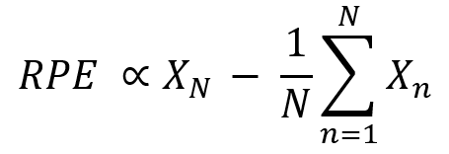

where x is the value of the fractal on trial n.

The second RPE then comes at the end of the trial after the computer's bid is revealed.

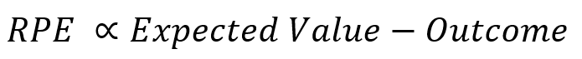
where

M is the magnitude of the budget (1.2ml), V is the subjective value of the fractal, and bid is the monkey's bid value. The expected values for a range of fractal values and bids are shown in supplementary figure 11.

The Outcome term is the value the monkey receives. When the auction is lost, this is M: the value of 1.2ml of water. In the win condition it equals
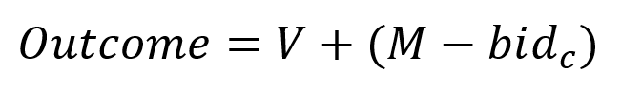
Where bid_{c} is the computer's bid.

The BDM offers 2 distinct advantages over traditional binary choice methods to reveal subjective value. Monkeys can make a continuous bid per trial, rather than relying on finding indifference points over entire blocks. This allows much greater temporal correlation between neurophysiological calculation, and behavioural reporting of value.

Theoretically, a single neuron’s response to a fractal could be regressed against a range of reported subjective values from that same neuron and same fractal. For instance, if the monkey prefers water early in an experimental block (i.e. when they are more water deprived and care more about liquid than taste), the lower subjective value of a fractal should be reflected in both lower bids and lower ‘neuronal valuation’.

Electrophysiological Targets
Initially, we will focus on recording dopaminergic reward prediction errors from the Substantia Nigra pars compacta and Ventral Tegmental Area in the midbrain of the animals. The RPE signal is a robust signal which tracks multiple rewards²².

Previous work has quantified the RPE using reinforcement learning models to calculate the monkey’s expected reward from each trial, based on a weighted average of past rewards¹². A limitation of this approach is it only reflects the physical properties of the reward (amount of water released) as it does not measure the internal, subjective valuation of this by the monkey, unlike the BDM. Thus, a replication of this work combined with more precise trial-by-trial subjective values reported by the monkeys bidding behaviour would be an initial aim.

The BDM also lends itself to the study of RPEs given the intrinsic uncertainty in the result of each trial. Unlike traditional binary choice tasks where the monkey chooses which reward it will receive, in the BDM it must make a bid and wait for the computer’s bid to resolve whether it has won that auction. There are two primary RPE signals I would hope to capture: the magnitude of the initial juice offered by a fractal, and the outcome of an auction trial. RPEs in midbrain dopamine neurons are known to integrate multiple reward dimensions (such as risk) in addition to magnitude¹³.

The medial orbitofrontal cortex (mOFC) is another potentially interesting brain region known to be involved in the representation of subjective value¹⁴, which has previously been studied in humans using a modified version of the BDM⁷. Participants made bids for food with a $3 budget and brain activity was measured using fMRI. An increase in the activity-related BOLD signal was detected in the mOFC after the display of the offered food, with a greater increase seen in trials where participants made larger bids. Given the relative heterogeneity of neuronal responses in the mOFC⁴, the richness of the BDM task, both in terms of the stimuli presented and the RPEs it should elicit, makes the mOFC an attractive candidate, though also opens the potential for multiple confounding stimuli-related responses.

Furthermore, the mOFC has been found to represent abstract rewards¹⁵, including probabilistic stimuli. By combining the probabilistic BDM (where for any bid, the monkey may still lose the auction) with the (otherwise identical) choice-based BCb, the dissociation of this risk signal may be possible. These higher-order cortical areas might also show 'mechanism dependence' in how they encode value. Though the BCb and BDM tasks are mathematically identical, and offer the same potential rewards per trial, it is possible that they elicit different neuronal representation, e.g. due to an endowment effect of spending a budget, rather than choosing a bundle. In comparison, reward-encoding dopaminergic midbrain cells tend only to reflect the total RPE at any given point.

Finally, it would be of interest to study the neuronal representation of loss in the BDM. In any trial of the BDM, the computer's bid might deviate from what the monkey expects, and the monkey might lose, or overpay, on a trial they did not expect to. RPEs can be negative as well as positive; midbrain dopamine neurons reduce their number of action potentials in response to an unexpected aversive stimulus. The firing rates of these dopaminergic neurons is known to influenced by glutamatergic neurons in the Lateral Habenula (LHb)^{16,17} though this has not been interrogated within economic decision making, and not using a task with complex RPEs. The precise control of costs per trial that we can exert via the distribution of computer bids makes the BDM especially suited for such experiments.

More recently, studies¹⁸ have implicated the LHb in depression. Application of Ketamine, an antagonist for NMDA receptors causes bursting behaviour in the LHb, inducing rapid antidepressant effects, hypothesised to be due to its downstream excitatory effect on midbrain dopaminergic circuits.

References
- Von Neumann, J., & Morgenstern, O. (1944). Theory of Games and Economic Behavior. Princeton University Press. https://doi.org/10.1177/1468795X06065810
- Montague, P. R., King-Casas, B., & Cohen, J. D. (2006). IMAGING VALUATION MODELS IN HUMAN CHOICE. Annual Review of Neuroscience. https://doi.org/10.1146/annurev.neuro.29.051605.112903
- Schultz, W., Dayan, P., & Montague, P. R. (1997). A neural substrate of prediction and reward. Science. https://doi.org/10.1126/science.275.5306.1593
- Padoa-Schioppa, C., & Assad, J. A. (2006). Neurons in the orbitofrontal cortex encode economic value. Nature. https://doi.org/10.1038/nature04676
- Kringelbach, M. L., O’Doherty, J., Rolls, E. T., & Andrews, C. (2003). Activation of the human orbitofrontal cortex to a liquid food stimulus is correlated with its subjective pleasantness. Cerebral Cortex. https://doi.org/10.1093/cercor/13.10.1064
- Becker, G. M., DeGroot, M. H., & Marschak, J. (1964). Measuring utility by a single-response sequential method. Behavioral Science. https://doi.org/10.1002/bs.3830090304
- Plassmann, H., O’Doherty, J., & Rangel, A. (2007). Orbitofrontal Cortex Encodes Willingness to Pay in Everyday Economic Transactions. Journal of Neuroscience. https://doi.org/10.1523/JNEUROSCI.2131-07.2007
- github.com/RobWHickman/MATisse
- Schultz, W. (2010). Dopamine signals for reward value and risk: Basic and recent data. Behavioral and Brain Functions. https://doi.org/10.1186/1744-9081-6-24
- Al-Mohammad, A. and Schultz, W. (2018) in preparation
- Enomoto, K., Matsumoto, N., Nakai, S., Satoh, T., Sato, T. K., Ueda, Y., … Kimura, M. (2011). Dopamine neurons learn to encode the long-term value of multiple future rewards. Proceedings of the National Academy of Sciences. https://doi.org/10.1073/pnas.1014457108
- Bayer, H. M., & Glimcher, P. W. (2005). Midbrain dopamine neurons encode a quantitative reward prediction error signal. Neuron. https://doi.org/10.1016/j.neuron.2005.05.020
- Lak, A., Stauffer, W. R., & Schultz, W. (2014). Dopamine prediction error responses integrate subjective value from different reward dimensions. Proceedings of the National Academy of Sciences. https://doi.org/10.1073/pnas.1321596111
- Sescousse, G., Redoute, J., & Dreher, J.-C. (2010). The Architecture of Reward Value Coding in the Human Orbitofrontal Cortex. Journal of Neuroscience. https://doi.org/10.1523/JNEUROSCI.3501-10.2010
- O’Doherty, J., Kringelbach, M. L., Rolls, E. T., Hornak, J., & Andrews, C. (2001). Abstract reward and punishment representations in the human orbitofrontal cortex. Nature Neuroscience. https://doi.org/10.1038/82959
- Matsumoto, M., & Hikosaka, O. (2007). Lateral habenula as a source of negative reward signals in dopamine neurons. Nature. https://doi.org/10.1038/nature05860
- Matsumoto, M., & Hikosaka, O. (2009). Two types of dopamine neuron distinctly convey positive and negative motivational signals. Nature. https://doi.org/10.1038/nature08028
- Yang, Y., Cui, Y., Sang, K., Dong, Y., Ni, Z., Ma, S., & Hu, H. (2018). Ketamine blocks bursting in the lateral habenula to rapidly relieve depression. Nature. https://doi.org/10.1038/nature25509

Supplementary Figure 1

Supplementary Figure 1: The BDM is mathematically identical to the BCb. Consider if the order of bidding in the BDM task was reversed. The monkey can choose to either bid above (to win the auction) or below (to lose) the computer’s bid. The position itself does not matter as the monkey pays either the computer bid (win) or nothing (lose). If the monkey chooses to win the auction he receives the fractal and an amount of water pre-decided by the computer bid. This is analogous to the payout in the bundle choice condition of the BCb. If the monkey chooses to lose, he receives on the budget, as he would receive if he chose away from the bundle in the BCb.

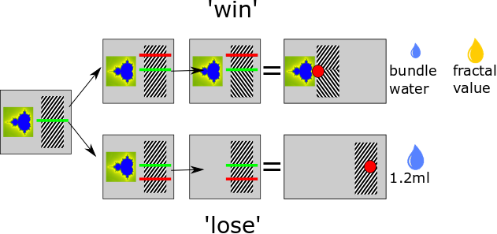

Supplementary Figure 2

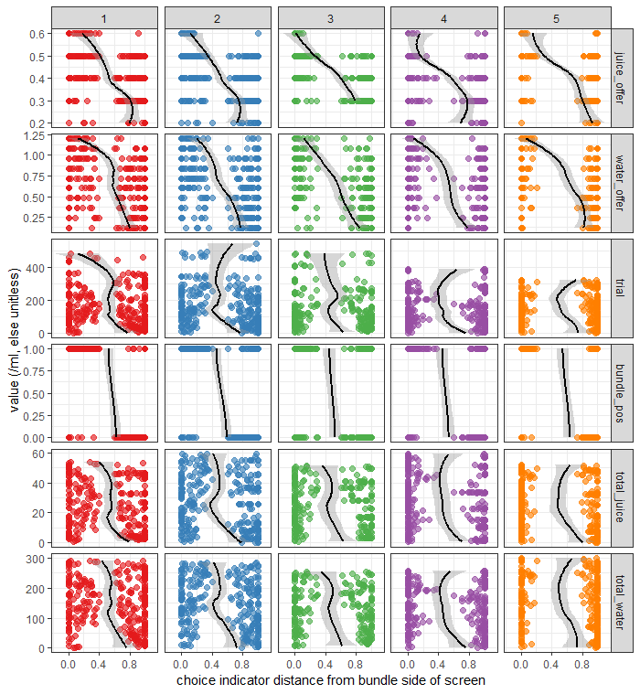
Supplementary Figure 2: Linear regression of variables against the monkey choice on a bundle task. Juice_offer = magnitude of juice in the bundle; water_offer = magnitude of water in the bundle; trial = trial number; bundle_pos = the side of the screen the bundle is on (1 = left, 0 = right); total_juice = the ml of juice the monkey has consumer so far that day; total_water = the ml of water the monkey has consumed that day. The x axis (bundle distance) shows the distance from the bundle side of the screen the monkey has moved their choice indicator to using a joystick. For instance, if a bundle is on the left hand side of the screen, a x axis value of 0 indicated that the monkey has moved their indicator all the way to the left hand side of the screen. A higher x value indicates that the monkey is choosing the budget over the bundle and vice versa.

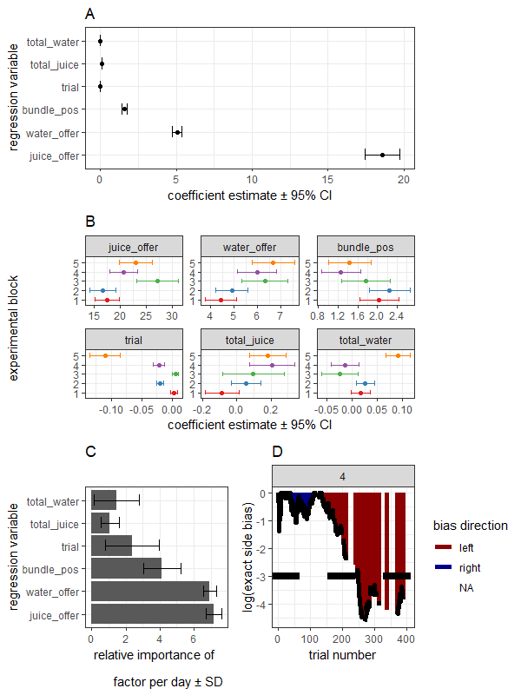
Supplementary Figure 3

Supplementary Figure 3: A) Regression coefficients for the bundle choice data shown in Figure 1. Factors were feed into a logistic regression model of fractal choice against the sum of variables for all days shown in Figure 1. Logistic regression models were generated using the binomial family of models for the glm() function from the stats library in R. The juice and water offered in each bundle, and the position of the bundle on the screen, were significant (p < 2x10⁻¹⁶) . Trial number was also significant p < 0.01 B) Regression coefficients shown for each day of training. Models were built as in A using only the data from a single day of monkey bundle choices. Coefficients showed stability over multiple days of testing C) The mean relative importance of each factor for the models of a single days behaviour. T statistics for each variable from a logistic model is calculated by comparing reductions in generalised cross-validation from variable reduction, and was performed using varIMP() from the caret library in R. D) The log exact side bias that the monkeys choices show for an example day. Side bias was calculated using a handwritten function utilising binom.test() from the stats library in R. Horizontal line shows significance a p = log(-2.996) = 0.05. Colour of the area over the line shows which direction the monkey shows a bias towards at that trial number. Missing areas indicate a failure on that trial.
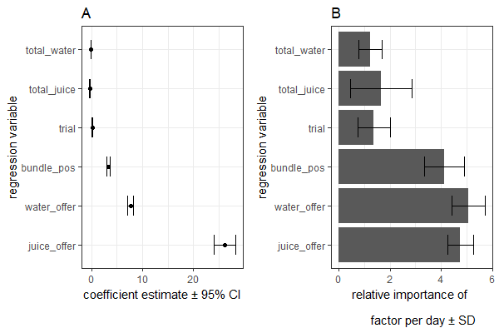
Supplementary Figure 4: A) Regression coefficients for the bundle choice data shown in Supplementary Figure 5- Monkey V’s performance on the BCb. Factors were feed into a logistic regression model of fractal choice against the sum of variables for all days shown in Figure 1. Logistic regression models were generated using the binomial family of models for the glm() function from the stats library in R. As with U, the juice and water offered in the bundle were the variables with by far the highest coefficient estimates and were significant p < 2x10⁻¹⁶. In contrast to monkey U, trial, date, and total water received were also significant p < 0.05, and total juice received in the block was significant p < 0.01. B) The mean relative importance of each factor for the models of a single day’s behaviour in monkey V. T statistics for each variable from a logistic model is calculated by comparing reductions in generalised cross-validation from variable reduction, and was performed using varIMP() from the caret library in R. Bundle position was much more important for monkey V (greater side bias) than monkey U in explaining choice behaviour.
Supplementary Figure 4

Supplementary Figure 5: Bundle Choice task data for monkey V in an example week. A)B) As with U, logistic regression of monkey V’s choice data showed clear transitivity between fractals shown in bundles and stability over multiple days of testing C) Pooling the bundle choice data allows us to gather the monkeys indifference point for a given magnitude of juice. Indifference points are calculated as the amount of water that needs to be offered in a bundle for a monkey to be expected to choose that bundle exactly 50% of the time. This is calculated from the logistic regression equations plotted in C. D) Indifference points for the 3 magnitudes of juice for the shown data. Indifference points were significant between juice fractals (p < 0.005).
Supplementary Figure 5

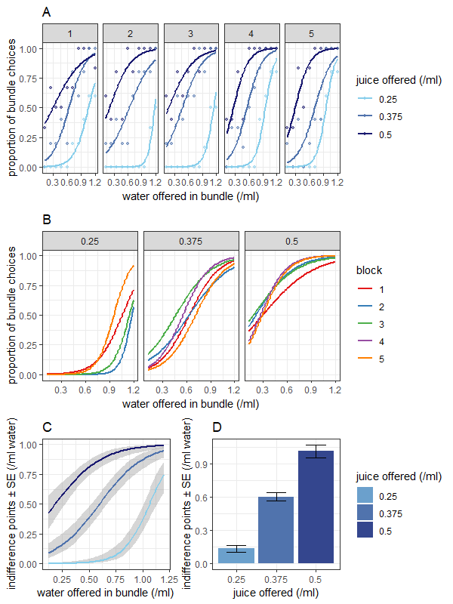
Supplementary Figure 6

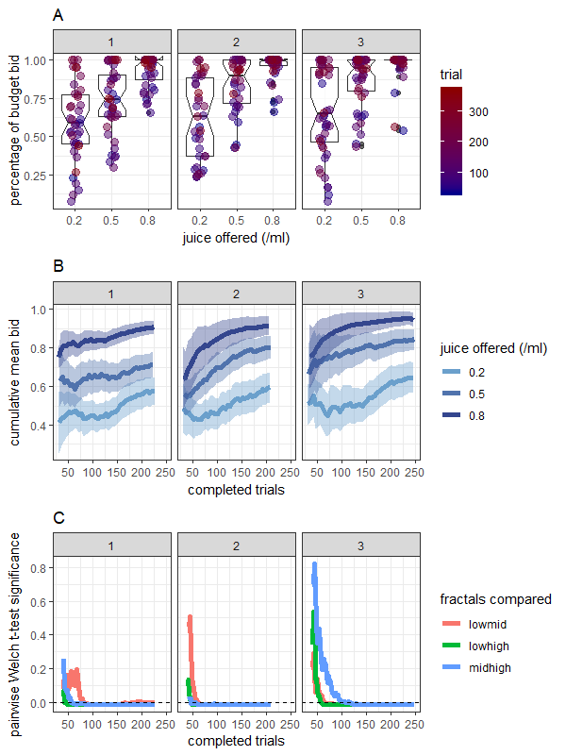

Supplementary Figure 6: More recent data for monkey U on the BDM task A) B) The monkey still separates bids by fractal offer magnitude, however, performs for fewer trials on average and with less separation of bids. Bidding behaviour also shows considerable effect of trial on final bid. C) Using a pairwise Welch test, bids still show significant separation on the BDM task (Bonferroni correct p < 0.0166)

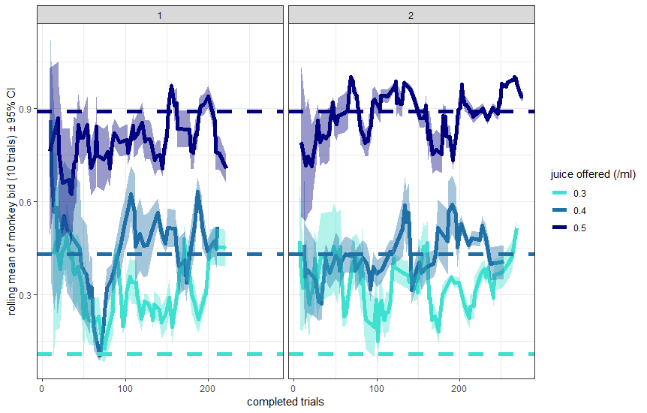
Supplementary Figure 7: Example calculation of rolling means of monkey bids per fractal over the course of two experimental blocks shown previously (figure 3). Rolling means and standard errors were calculated using rollapply from the zoo library in R using a window of the last 10 bids. Horizontal lines indicate indifference points as calculated using the BCb for each fractal, as in figure 3B. Even given the variation in bidding (figure 4D) and the use of a relatively small window (10 bids ~ 1 minute), fractals bids show significant differences at the 95% confidence interval for a substantial chunk of the experimental block.
Supplementary Figure 7

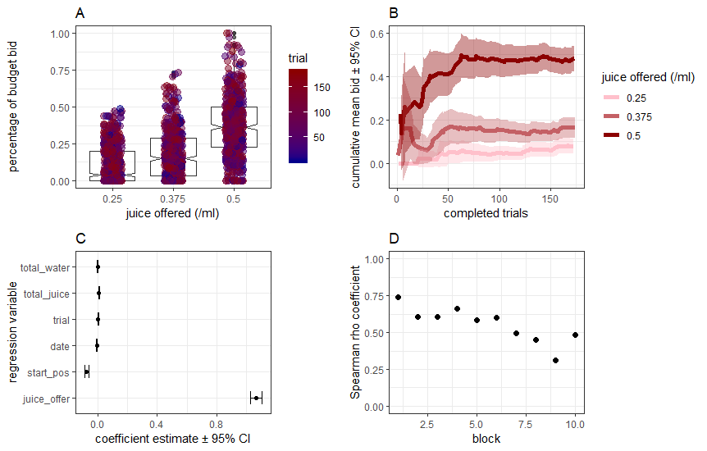
Supplementary Figure 8

Supplementary Figure 8: Data from monkey V on the first price auction task. Data pooled from two weeks of experiments. A) Pooled monkey bids show significant differences in final bid between trials with different amounts of juice offered to the monkeys (p < 2x10⁻¹⁶). B) An example session from the dataset. Monkey bids tend to separate quickly, though due to the low bids, differences between the lowest two fractals, means may overlap. C) Regression coefficients for the BDM data shown in A). Factors were feed into a linear regression model of the monkeys final bid position as a fraction of the total budget against the sum of variables. Linear regression models were generated using the binomial family of models for the lm() function from the stats library in R. The juice offered on each trial was significant (p < 2x10⁻¹⁶). The starting position of the bid (p < 0.0000005) and the date of the block (p < 0.000005) were significant. In contrast to Monkey U’s BDM data, the total_juice V had consumed had a significant effect (p < 0.05). The juice offered in each trial had by far the largest regression coefficient. D) Spearman’s rho coefficients were lower than those that had previously been gathered from the monkey¹⁰ in similar conditions on a BDM task. Over the two weeks they held steady in the range of 0.5-0.625 aside from two outliers. A linear regression of this data showed a weak negative effect of block number on Spearman’s rho coefficient (estimate = -0.03, p < 0.05)

Supplementary Figure 9

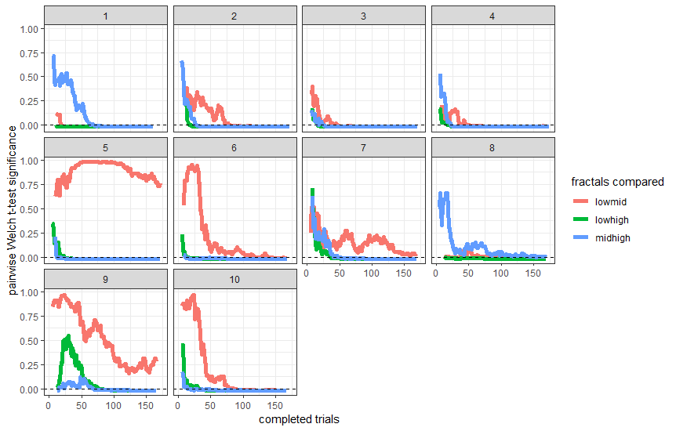
Supplementary Figure 9: Data from monkey V on the first price auction task. Data pooled from two weeks of experiments. Pairwise Welch’s t-tests showed that all 3 combinations of fractals tended to diverge significantly (Bonferroni corrected p < 0.0166) within roughly 100 trials. For some blocks, the lowest and middle fractal offer (0.25 and 0.375ml juice respectively) do not significantly diverge.

Supplementary Figure 10

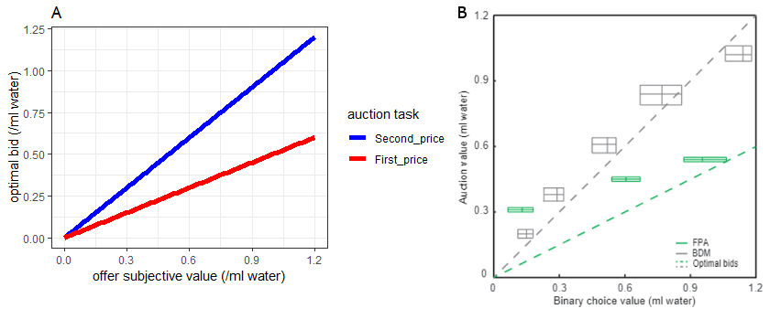
Supplementary Figure 11

Supplementary Figure 10: A) Unlike in the BDM auction task, which is incentive-compatible, the optimal strategy for first price auctions is to shade ones bid. The degree of shading depends on the distribution of opponent bids- for a uniform distribution such as we are using, the optimal bid is always exactly half of the perceived subjective value of the good. B) Preliminary data gathered from monkey V on the first price auction task by Marius Posa indicates that the monkey may switch bidding strategies between the BDM (second price) task and the first price auction task. However, BDM auction data used with permission from¹⁰
was gathered a year before and may not be relevant for comparison.

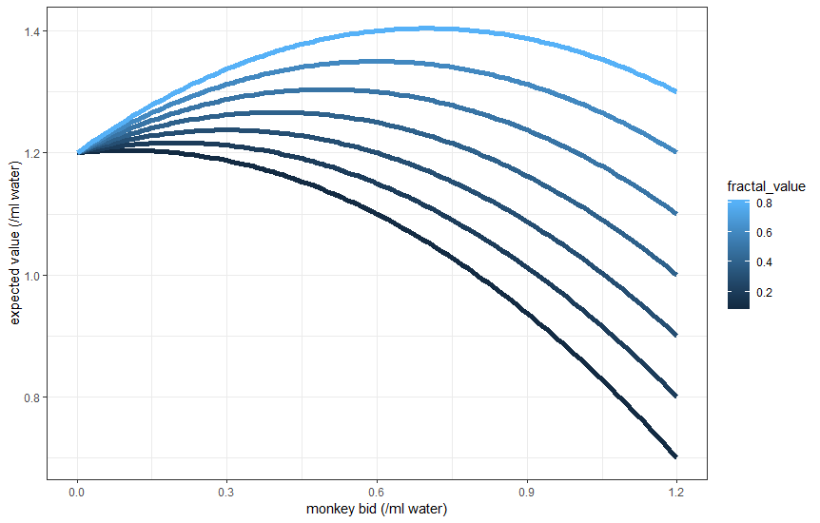

Supplementary Figure 11: The monkey's expected value of any trial on the BDM is governed by 3 factors: their bid, the subjective value of the fractal offered, and the magnitude of the budget. Given a fixed 1.2ml budget magnitude, expected value is shown for fractals valued at 0.1 to 0.8ml of water. The expected value for bids between 0ml of the budget and 1.2ml of the budget in increments of 0.01ml are plotted. The maximum expected value for any subjective fractal value-bid pair is when the bid is exactly equal to this subjective valuation.

